**Forms for registration, B2B, participant profile and corporate profile**

**Registration Form**

Please provide details of person(s) who will be representing your organization:

Organization Name: EMIRATES MACARONI FACTORY LLC

Website: emiratesmacaroni.com

Represented By#1: AHMAD BELYOUHA Represented By#2:

Position: CHAIRMAN Position:

Tel: 04-3388333 Tel:

Mobile: 050-6544443 Mobile:

E-mail: ahmad@emf.ae E-mail:

|  |  |  |  |
| --- | --- | --- | --- |
| Company Profile | | | |
| **1. Name of Company:  EMIRATES MACARONI FACTORY LLC** | | | |
| **2. Address: AL QOUZ 1 BESIDE DUBAI REFRESHMENT SHEIKH ZAYED ROAD DUBAI UAE** | | **3. Telephone (with international code):**  **0097143388333** | |
| **4. City :**  DUBAI | | **5. Fax (with international code) :**  **0097143382000** | |
| **6. Country** :  UNITED ARAB EMIRATES | | **5. Contact E-Mail** :  info@emf.ae | |
| **7. Contact Person**: **Title:**  ROWENA F. SEVILLA EXECUTIVE ASSISTANT | | | |
| **8. Legal Status (e.g. Partnership, LLC, Listed Company, etc**)  LIMITED LIABILITY COMPANY (LLC) | | | |
| **9. Year Established: 1979** | **10. Website url:**  **Emiratesmacaroni.com** | | |
| **11. Company Profile (max 200 words)**  Emirates Macaroni Company LLC was established in 1979 and is currently one of the major pasta suppliers in the region and abroad. EMF holds a large percentage of local market share, market leadership, strong and respected brand loyalty being an ISO & HACCP certified company. EMF products are well presented in more than 23 countries spreading over all the 6 continents. EMF caters to retail customers and HORECA sectors through our network of exclusive distributors who ensures that our products are available in every shelf within their assigned territories. EMF also caters to private label partners who trusts our quality and service levels to be associated with their brands which includes renowned large chains and companies in the region. EMF aims to gain consumer’s trust and have our brands dominating each categories in all the markets that we serve. | | | |
| **12. Product / Service** | | | **HS Code (if available)** |
| EMIRATES MACARONI | | | 19021110 |
| VERDA | | |  |
| PASTA HAT | | |  |
| DUBAI MACARONI | | |  |
| AL WOROOD | | |  |
| **13. Please paste images of your products (Maximum ONE page)** | | | |

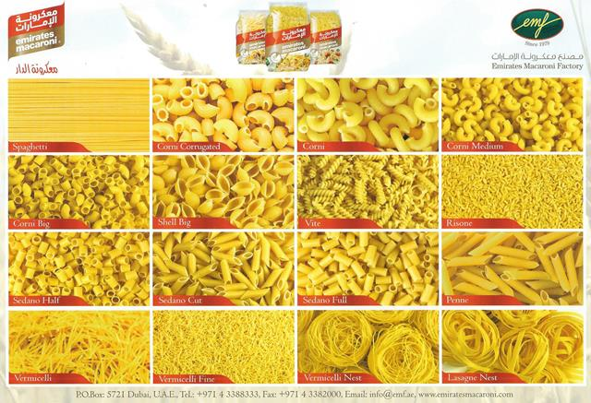

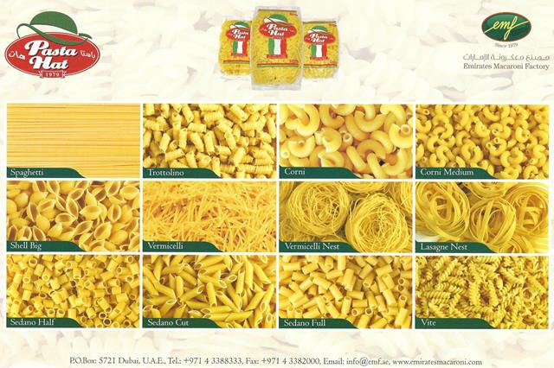

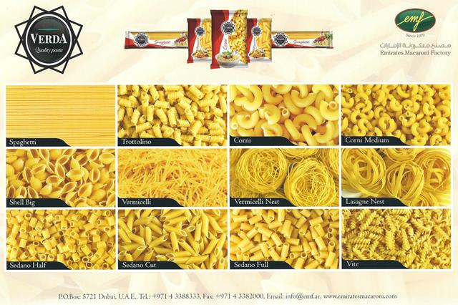

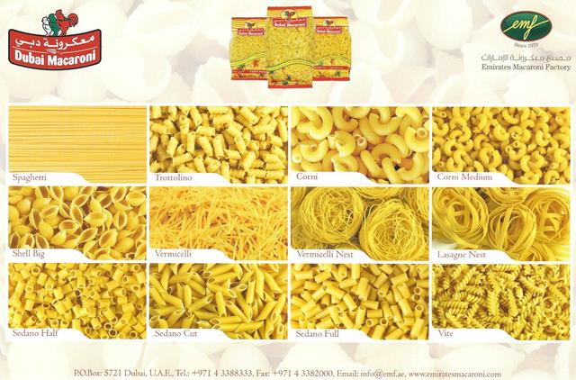

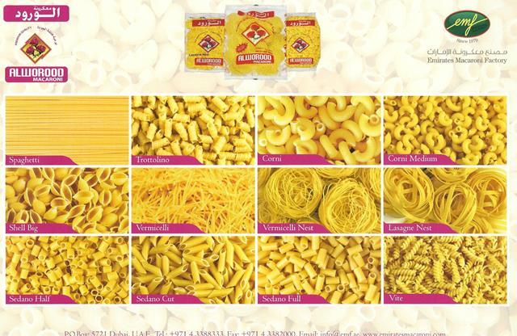

**Participant Profile Form**

|  |  |
| --- | --- |
| cid:image001.png@01D392C4.CFFEE470 | |
| INSERT PARTICIPANT PHOTOGRAPH HERE    C:\Users\rowena.EMF\Documents\ROWENA\EMF FILES & DOCUMENTS\EXECUTIVE MANAGEMENT\AHMAD BELYOUHA\LEGAL DOCUMENTS\Ahmad Saeed Majed Belyouha\CHAIRMAN Official Photo.jpg | ***Name:***  **AHMAD BELYOUHA** |
| ***Position:***  ***CHAIRMAN*** |
| ***Email: ahmad@emf.ae***  ***Office Telephone Number: 0097143388333***  ***Mobile Telephone Number: 00971506544443***  ***Address: AL QOUZ IND. 1 SHK ZAYED RD DUBAI UAE***  ***Website: emiratesmacaroni.com*** |
| ***Participant Background*** | |
| A young entrepreneur and businessman at heart. He is a business leader who is personally overseeing the family business involved in food manufacturing, real estate and engineering/consultancy.  He is currently the Chairman of Emirates Macaroni Factory. | |

**PLEASE COMPLETE A NEW PARTICIPANT PROFILE FORM FOR EACH REPRESENTATIVE ATTENDING THE MISSION**

**B2B Meeting *Registration Form***

**Company Details**

|  |  |
| --- | --- |
| **Name of Company** | EMIRATES MACARONI FACTORY |
| **Industry of Company** | FMCG |
| **Address of Company** | AL QOUZ 1 SHEIKH ZAYED RD DUBAI UAE |
| **Website Address** | Emiratesmacaroni.com |

**Participant Details**

|  |  |  |
| --- | --- | --- |
| **Participant #1** | **Name** | AHMAD BELYOUHA |
| **Position** | CHAIRMAN |
| **Mobile Number (UAE)** | 00971506544443 |
| **Email Address** | ahmad@emf.ae |

|  |  |  |
| --- | --- | --- |
| **Participant #2** | **Name** |  |
| **Position** |  |
| **Mobile Number (UAE)** |  |
| **Email Address** |  |

**Please Provide a General Overview of the Type of Organisation that You Would like to Meet and which industry you are interested in?**

|  |
| --- |
| Companies involved in the food sector, food processing and manufacturing, packaging and raw materials supply and handling |

**Type of Co-operation (please tick as appropriate)**

|  |  |  |  |  |  |
| --- | --- | --- | --- | --- | --- |
| Buyers |  | Investors |  | Licensing |  |
| Agents/Distributors |  | Joint Venture Partners |  | Suppliers |  |
| Potential Franchisees |  | Technical Co-operation |  | Other – please state below |  |

**Pre-Identified Companies – list any company that you have had previous contact with or identified whom you would like to meet again (please include as much information as possible).**